S LINE AUTOMOBILES
SPECIALISTS IN AUDI & VOLKSWAGEN
WE OFFER THE FOLLOWING
SPECIALIZED DIAGNOSTICS
MAJOR & MINOR SERVICING
SUSPENSION REPAIRS
BRAKE & CLUTCH OVERHAULS
PICK UP & DROP OFFVEHICLES OR CLIENTS
BREAKDOWN & ON SITE REPAIRS

CONTACT US FOR BOOKINGS AND FREE QUOTATIONS
ADDRESS: LOT 52 VINCENT DICKENSON ROAD,COTTONLANDS,KZN
POSTAL ADDRESS: PO BOX 576 VERULAM 4340
CONTACT NO: 084 924 1001
E-MAIL ADDRESS: SLINEAUTO@HOTMAIL.CO.ZA
WEBSITE: WWW.SLINEAUTOMOBILES.COM
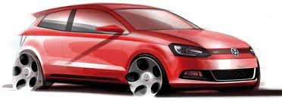
WWW.EEZIADS.CO.ZA

